LAB 4
- Write a Java program to accept an integer value from the user and convert it into a byte. Display the result and observe the effect when the entered value exceeds the byte range.

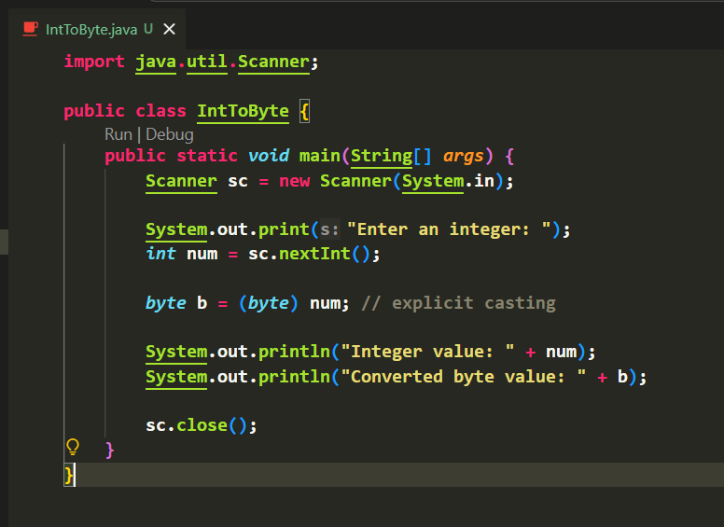
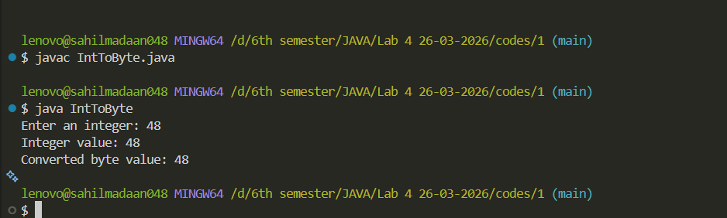
OUTPUT:

OUTPUT:
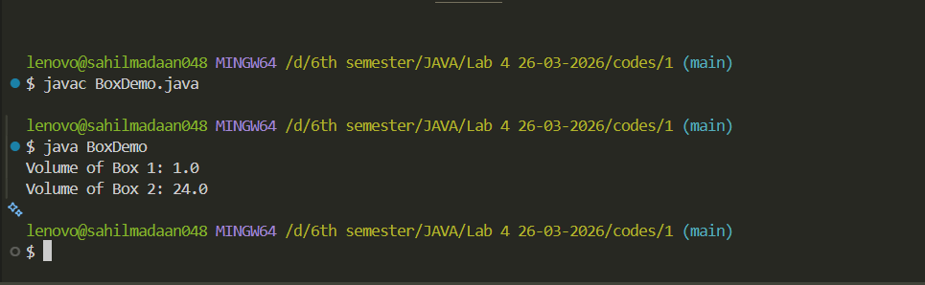

LAB 4
- Write a Java program to create a class Box with:
- Instance variables: length, breadth, height
- Constructors:
  - Default constructor
  - Parameterized constructor
- Method: volume()
Create objects using both constructors and display the volume.
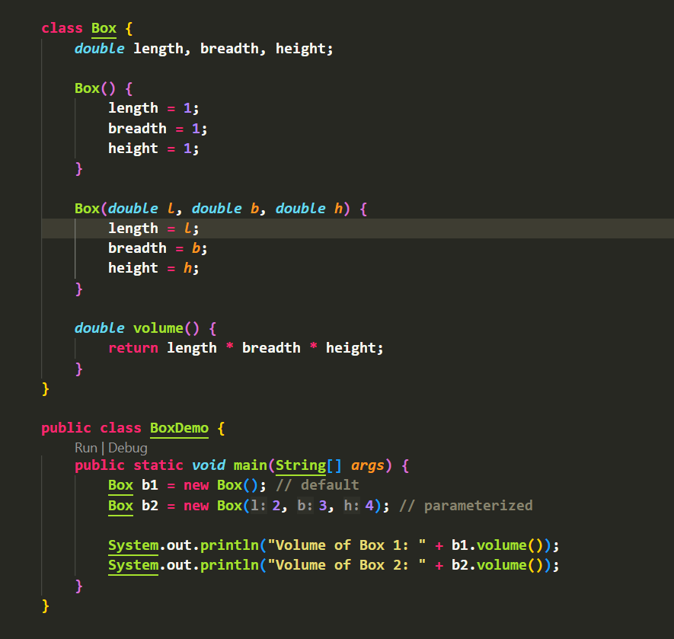

OUTPUT:

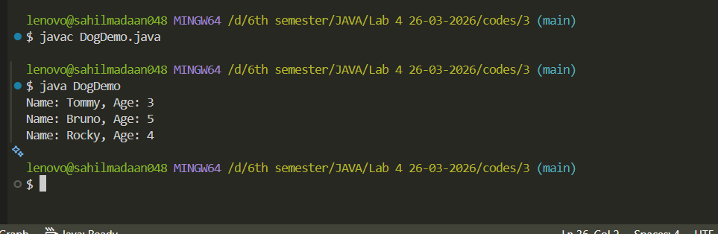

LAB 4
- Write a Java program to create a class Dog with:
- Instance variables: name, age
- Method: display() to print details
- Initialize the object using:
  - Reference variable
  - Method
  - Constructor
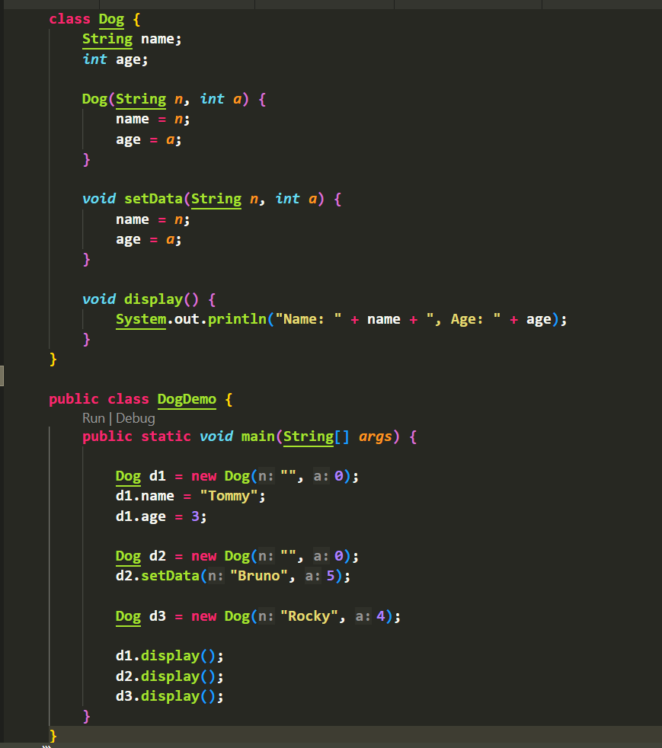
Display the values for each initialization technique.

OUTPUT:
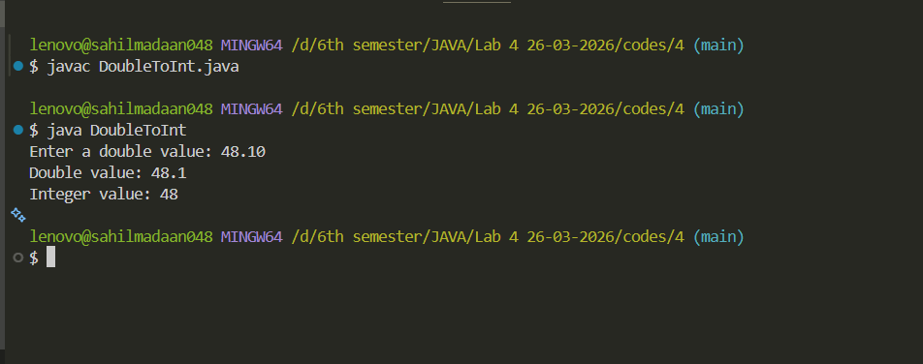

LAB 4
- Write a Java program to accept a double value from the user and convert it into an integer using explicit type casting. Display both values.

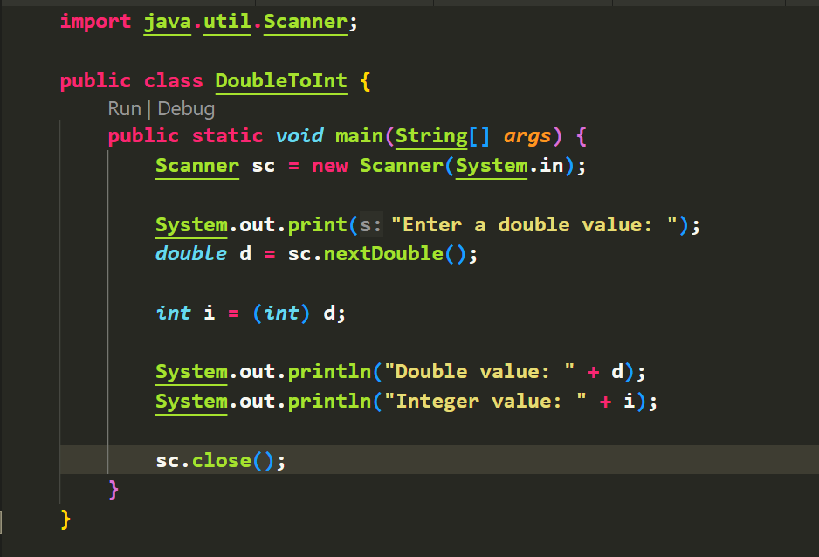

OUTPUT:
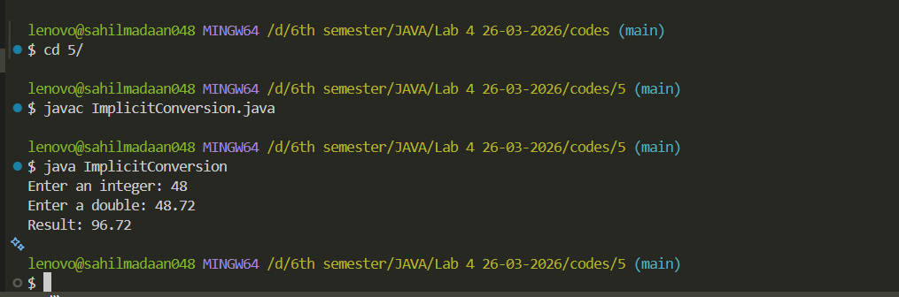

LAB 4
- Write a Java program to accept two numbers from the user: one integer and one double. Perform addition and display the result after implicit type conversion.

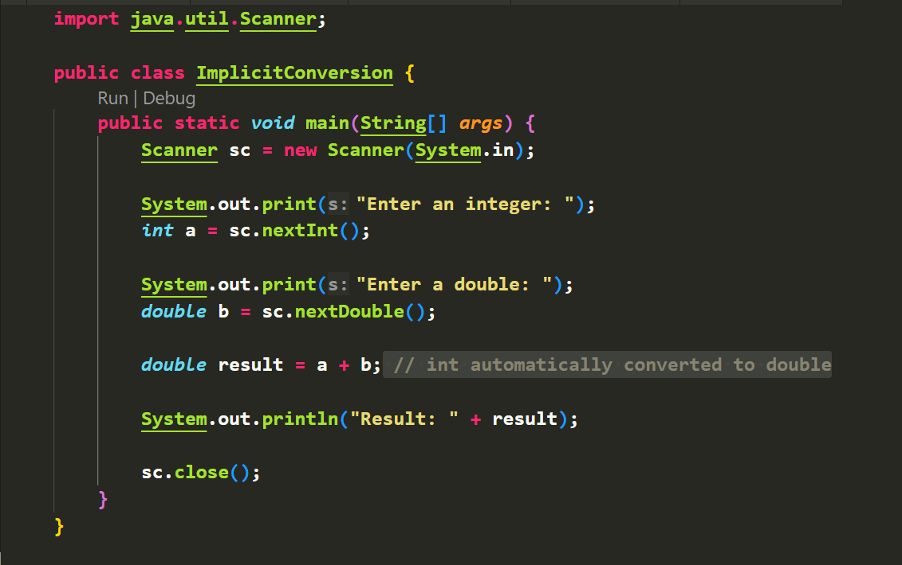

OUTPUT:

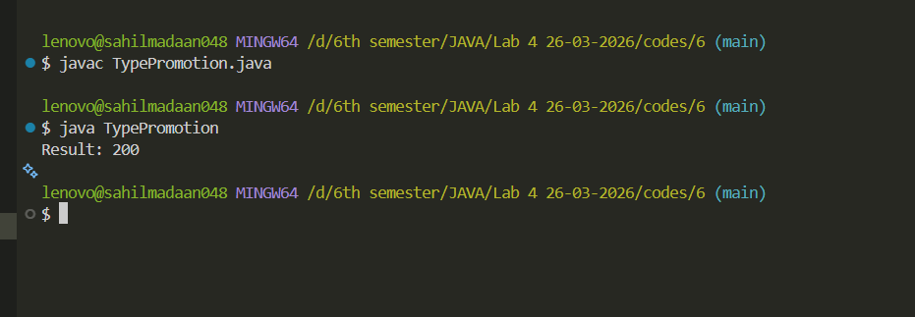

LAB 4
- Write a Java program to demonstrate type promotion by multiplying two byte variables and storing the result in an integer variable. Display the result.

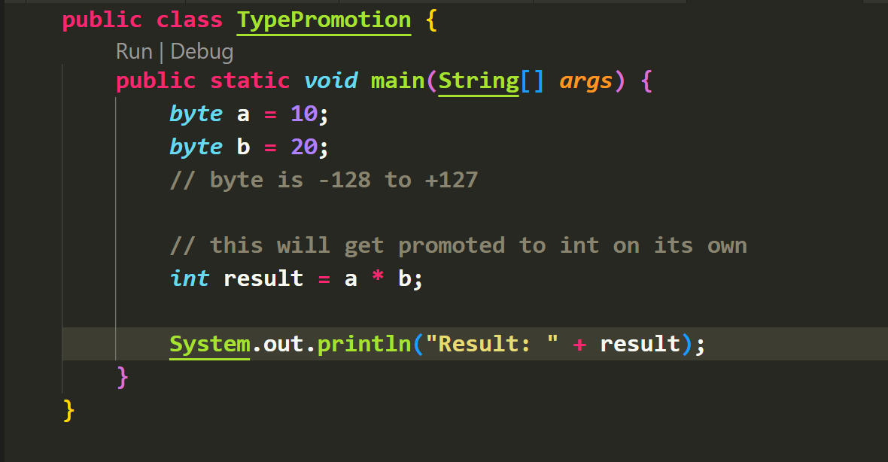

OUTPUT:
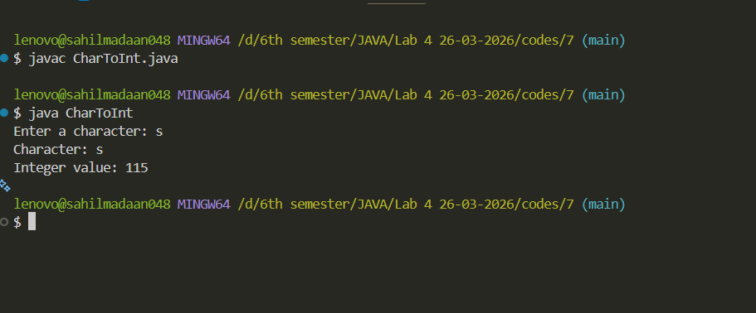

LAB 4
- Write a Java program to accept a character from the user, convert it into its corresponding integer value, and display the result.

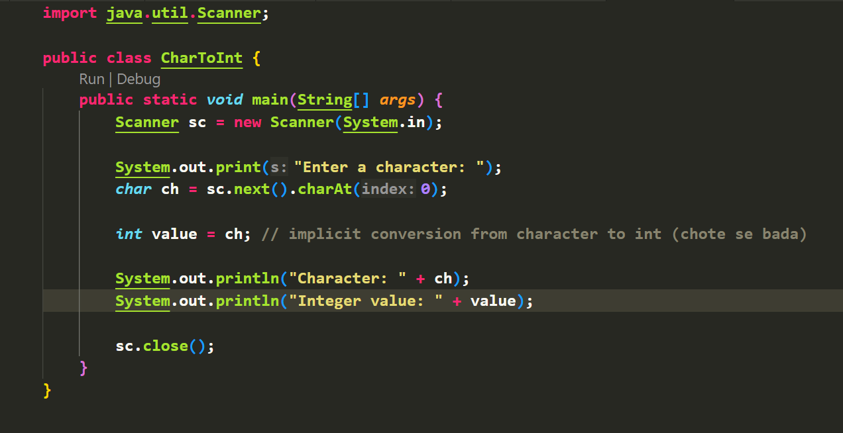

OUTPUT:
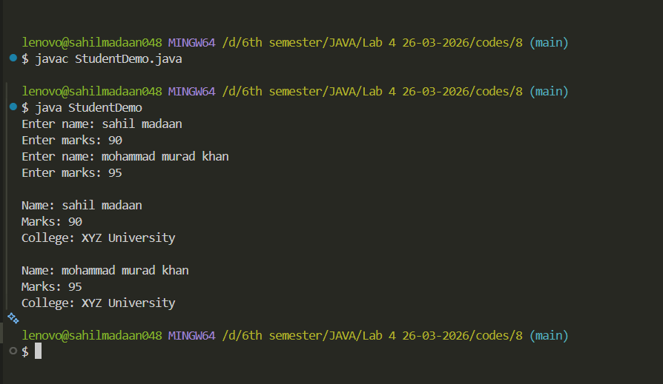

LAB 4
- Write a Java program to create a class Student with:
- Instance variables: name, marks
- Static variable: collegeName
- Methods:
  - input()
  - display()
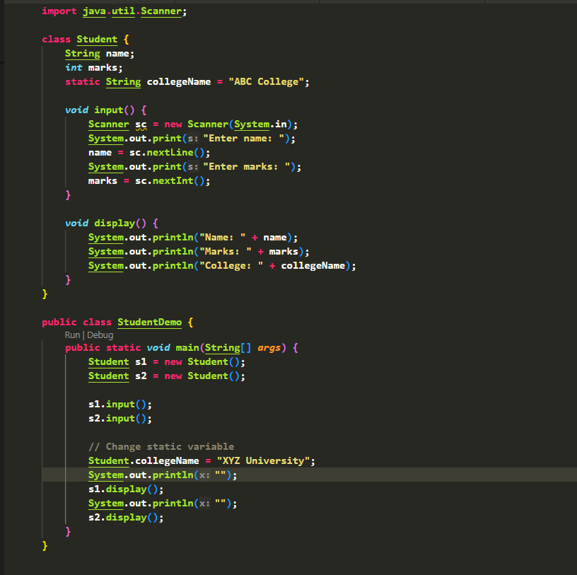
Create two objects and demonstrate that the static variable is shared among all objects.

